AWS RDS MYSQL HANDS-ON LAB DOCUMENTATION

EC2 → RDS MySQL → Security Group → Database → Read Replica → Snapshot → Restore

1. LAB OBJECTIVE
The objective of this lab is to create and configure an Amazon RDS MySQL database and connect to it from a Linux EC2 instance.
The lab demonstrates the following AWS concepts:
- Amazon EC2
- Amazon RDS
- MySQL
- VPC
- Subnet
- Security Groups
- TCP port 3306
- MySQL Client
- Database creation
- Tables and records
- Read Replicas
- Replication
- RDS Snapshots
- Database Restoration
- Basic troubleshooting
- AWS resource cleanup
The overall workflow is:
Create EC2
↓
Create RDS MySQL
↓
Configure VPC and Subnet
↓
Configure RDS Security Group
↓
Allow TCP 3306 from EC2 Security Group
↓
Connect EC2 to RDS
↓
Create Database
↓
Create Table
↓
Insert Data
↓
Create Read Replica
↓
Verify Replicated Data
↓
Delete Source Database – Lab Test
↓
Verify Replica
↓
Create RDS Snapshot
↓
Restore Snapshot
↓
Verify Restored Database
↓
Clean Up Resources
The supplied lab documentation follows this same overall workflow.

2. AWS ARCHITECTURE
The Linux EC2 instance is used as the client machine.
The EC2 instance connects to the RDS MySQL database through the AWS VPC network.
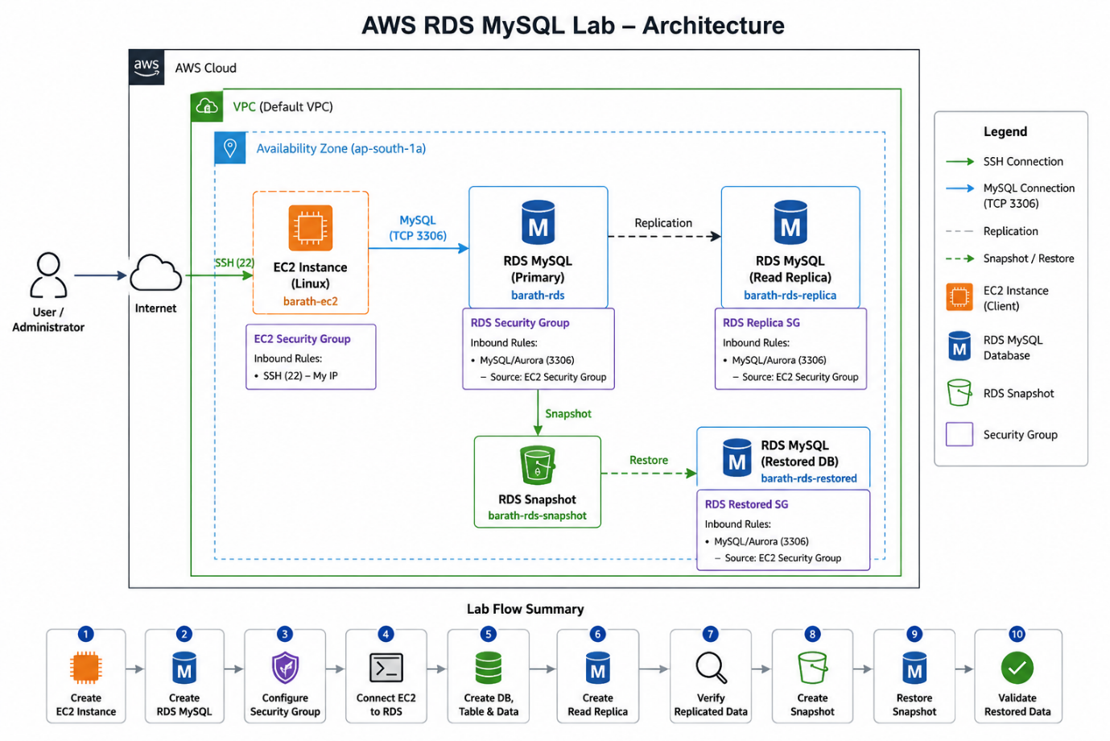

AWS CLOUD

┌──────────────────────┐
│ VPC │
│ │
│ ┌──────────────┐ │
│ │ EC2 │ │
│ │ Linux Server │ │
│ └──────┬───────┘ │
│ │ │
│ │ TCP 3306 │
│ ↓ │
│ ┌──────────────┐ │
│ │ RDS │ │
│ │ MySQL │ │
│ └──────────────┘ │
│ │
└──────────────────────┘
The EC2 instance communicates with RDS using the MySQL protocol over TCP port 3306.

3. PREREQUISITES
Before starting the lab, the following are required:
- AWS account.
- Linux EC2 instance.
- EC2 key pair.
- EC2 Security Group.
- RDS MySQL database.
- RDS Security Group.
- VPC and subnet.
- MySQL client.
- SSH client.
- Basic Linux commands.
- Basic SQL commands.
Important Security Requirement
The RDS Security Group must allow MySQL traffic from the EC2 instance.
Protocol : TCP
Port : 3306
Source : EC2 Security Group
The reference documentation specifically requires a database Security Group that allows MySQL/Aurora TCP 3306 traffic from the EC2 instance/security group.

4. STEP 1 – CREATE EC2 INSTANCE
4.1 Open Amazon EC2
Log in to the AWS Management Console.
Go to:
AWS Console
↓
EC2
↓
Instances
↓
Launch Instance
Screenshot 1 – EC2 Console
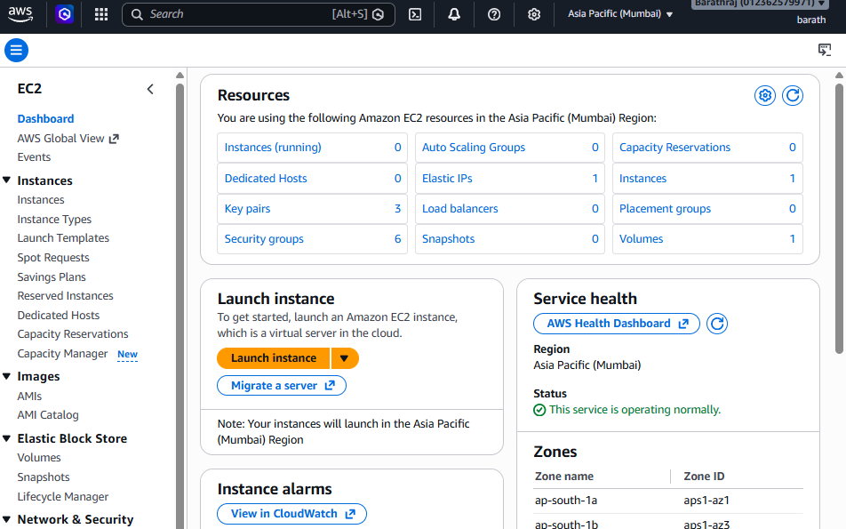Screenshot Explanation
This screenshot shows the Amazon EC2 console.
Amazon EC2 provides virtual servers that can be used to run applications, services, and administrative tools.
In this lab, the EC2 instance will be used as the Linux client machine that connects to the Amazon RDS MySQL database.

5. STEP 2 – CONFIGURE EC2 INSTANCE
Configure the following:
- Instance Name
- AMI
- Instance Type
- Key Pair
- VPC
- Subnet
- Security Group
- Storage
Screenshot 2 – EC2 Configuration
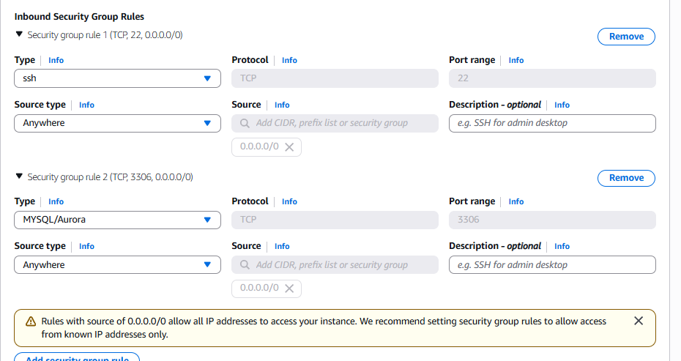Screenshot Explanation
This screenshot shows the configuration used to create the Linux EC2 instance.
The AMI determines the operating system, while the instance type determines the compute resources such as CPU and memory.
The key pair is used to securely connect to the Linux instance using SSH.

6. STEP 3 – CONFIGURE EC2 SECURITY GROUP
The EC2 instance requires SSH access.
Configure:
Type : SSH
Protocol : TCP
Port : 22
Source : My IP / Trusted IP
Screenshot 3 – EC2 Security Group
Screenshot Explanation
This screenshot shows the Security Group associated with the EC2 instance.
The inbound SSH rule allows the administrator to connect to the Linux EC2 instance using SSH.
TCP port 22 is the standard SSH port.
For security, SSH access should preferably be restricted to a trusted IP address.

7. STEP 4 – LAUNCH EC2
Review the configuration and click:
Launch Instance
Wait until:
Instance State → Running
Screenshot 4 – EC2 Running
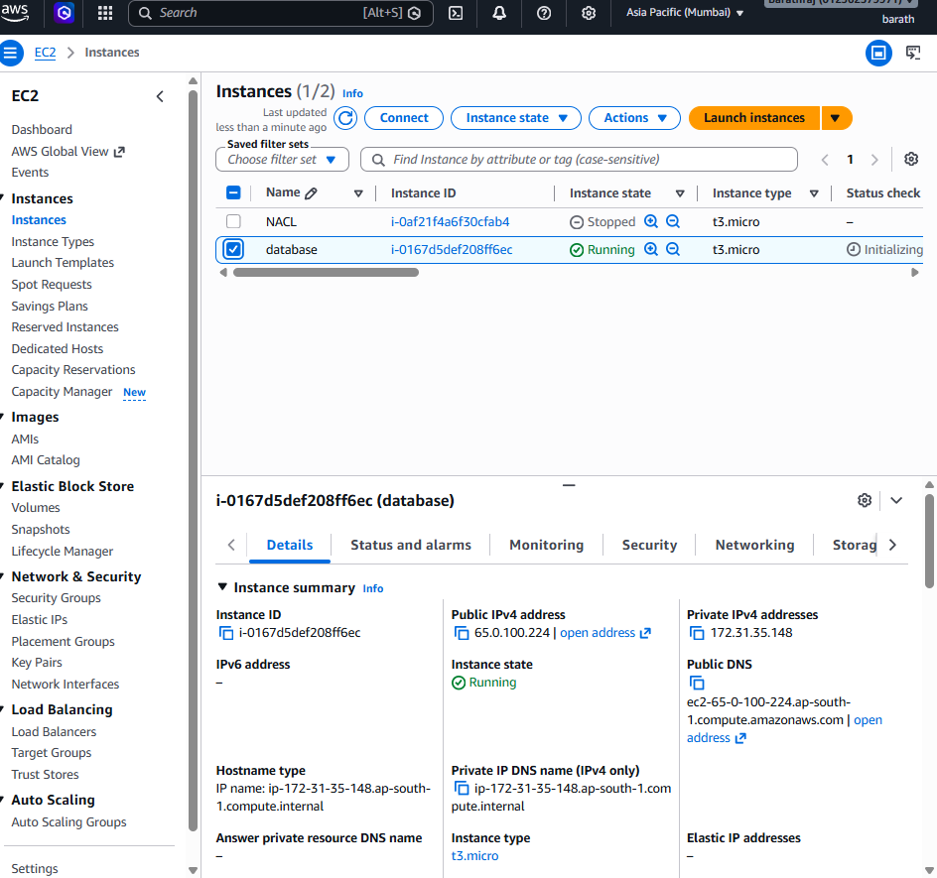Screenshot Explanation
This screenshot confirms that the Linux EC2 instance has been successfully launched.
The instance is now running and can be accessed through SSH.

8. STEP 5 – OPEN AMAZON RDS
Go to:
AWS Console
↓
RDS
↓
Databases
↓
Create Database
Screenshot 5 – RDS Console
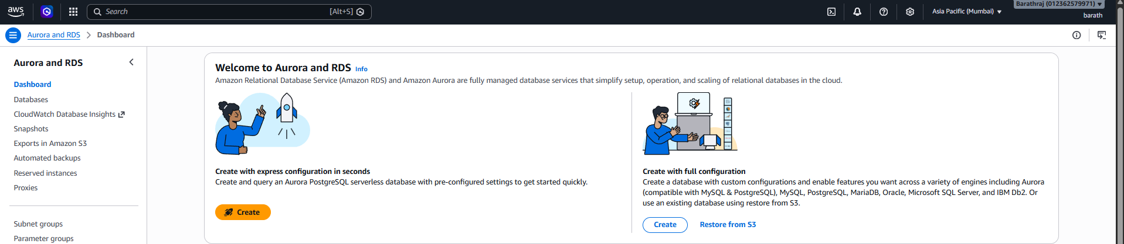

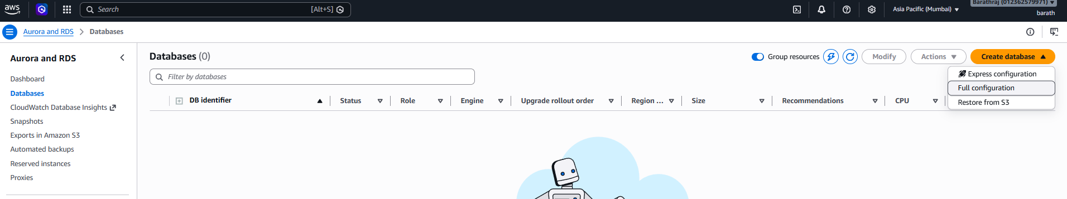Screenshot Explanation
This screenshot shows the Amazon RDS console.
Amazon RDS is a managed relational database service that allows us to create and operate relational databases without manually managing the underlying database infrastructure.

9. STEP 6 – SELECT DATABASE ENGINE
Select:
Engine → MySQL
The supplied lab reference uses MySQL Community.
Screenshot 6 – MySQL Engine
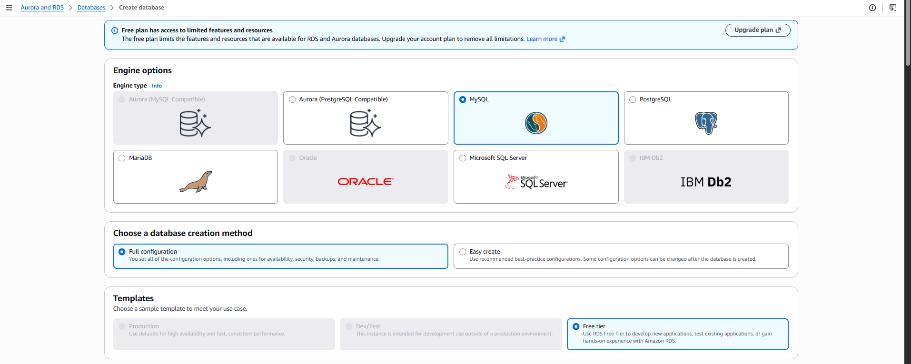
Screenshot Explanation
This screenshot shows the MySQL database engine selected for the RDS database.
MySQL is a relational database management system in which structured data is stored in tables containing rows and columns.
Amazon RDS manages many infrastructure and database administration tasks while allowing users to work with the MySQL database.

10. STEP 7 – SELECT MYSQL VERSION
Select the required supported MySQL version.

the MySQL version selected during database creation.
The database engine version determines the database features, compatibility, and supported functionality available to the database.

11. STEP 8 – AVAILABILITY AND DURABILITY
Configure the required availability option.
Screenshot 8 – Availability and Durability
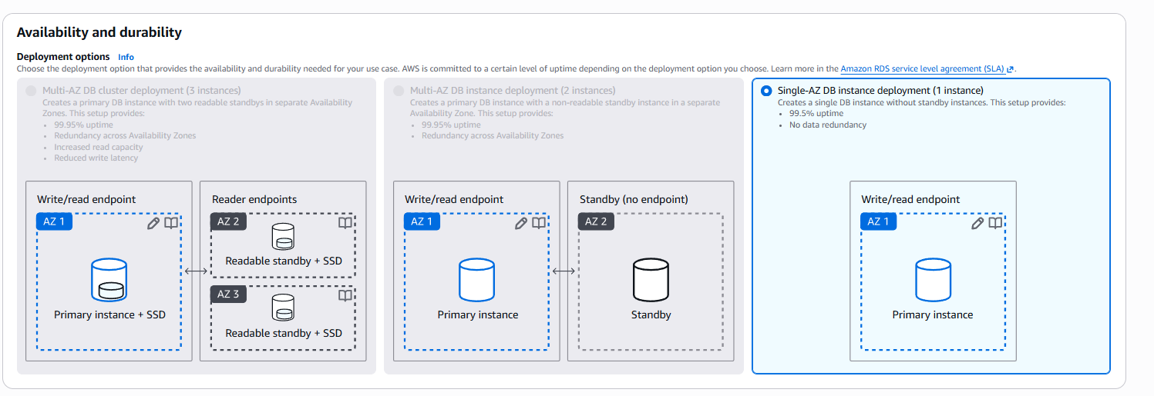Screenshot Explanation
This screenshot shows the availability and durability configuration for the RDS database.
For production workloads, Multi-AZ configurations can be used to improve database availability and provide failover capabilities.
Important Concept
Multi-AZ
↓
High Availability
↓
Failover
A Read Replica is different from Multi-AZ because a Read Replica is primarily intended for read scalability.
The lab documentation also identifies Multi-AZ as a high-availability/failover feature and Read Replicas as a read-scaling feature.

12. STEP 9 – CONFIGURE RDS CREDENTIALS
Configure:
Master Username
Master Password
Screenshot 9 – RDS Credentials
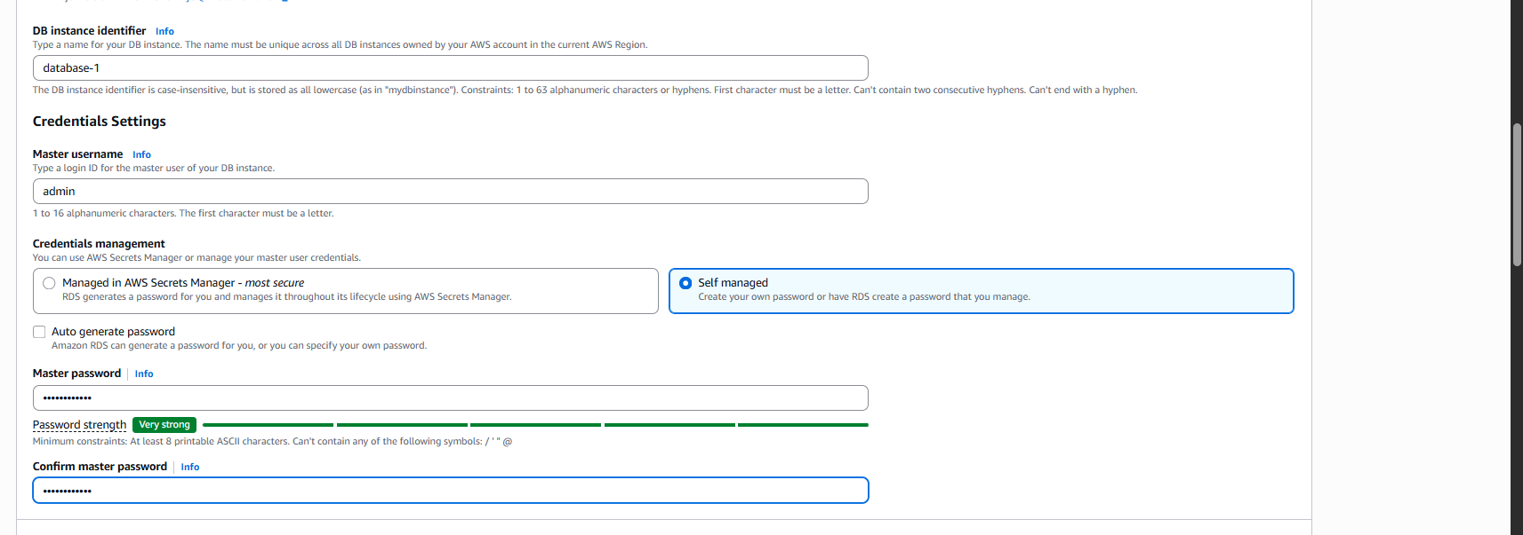Screenshot Explanation
This screenshot shows the master database credentials configured during RDS creation.
The master username is used to authenticate to the database.
The database password must be kept confidential.
Security Note
Do not show the real password in:
- Screenshots
- Word documents
- GitHub
- WhatsApp
- Resume
- Public websites
Use:
********
when documenting credentials.
The lab documentation also specifically instructs that real passwords should not be included in screenshots or training documents.

13. STEP 10 – CONFIGURE STORAGE
Configure the required storage.
The supplied lab reference uses general-purpose SSD storage.
Screenshot 10 – RDS Storage
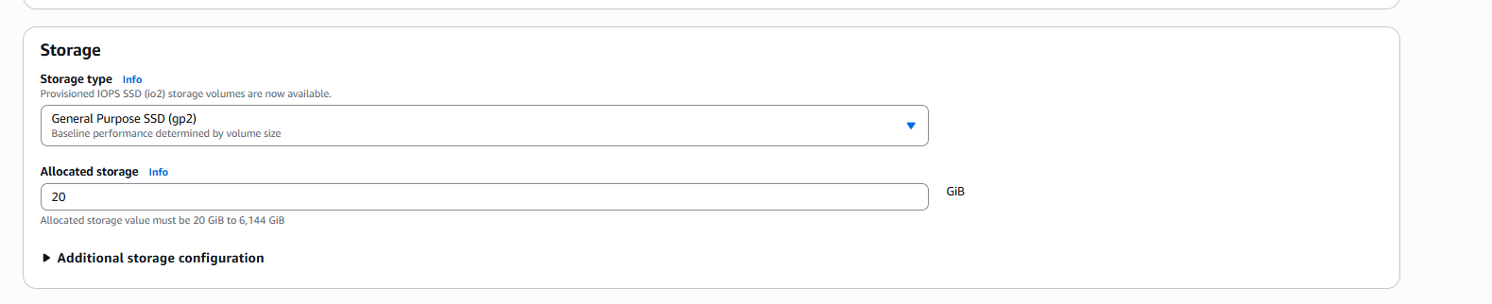Screenshot Explanation
This screenshot shows the storage configuration for the RDS database.
The storage configuration determines the storage type and amount of storage available to the database.
Storage should be selected according to workload requirements and expected database growth.

14. STEP 11 – CONFIGURE VPC
Select the required VPC.
If you have then make the or use the default VPC
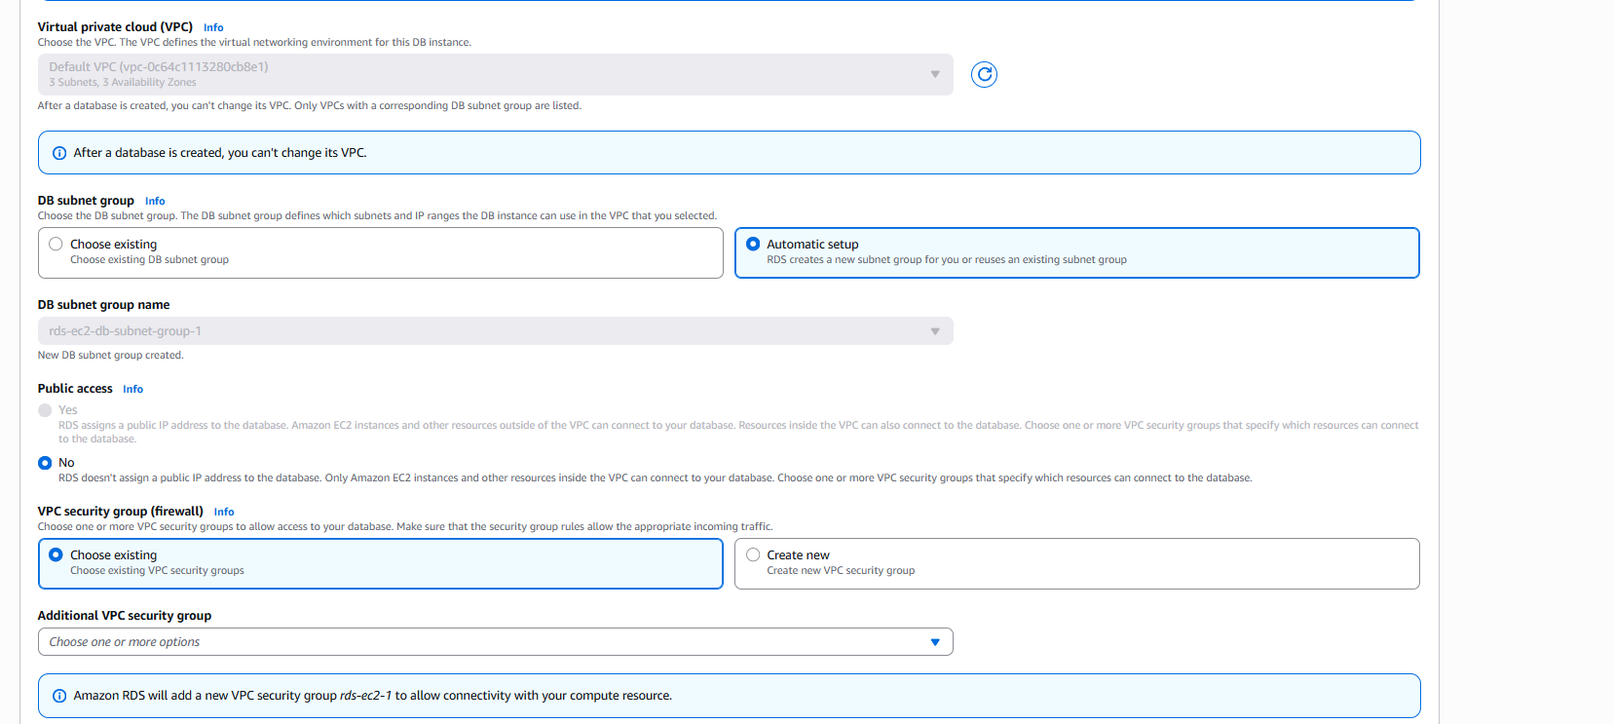
This screenshot shows the VPC selected for the RDS database.
A VPC provides the network environment in which AWS resources such as EC2 and RDS communicate.
For this lab, the EC2 instance and RDS database need to have network connectivity.

15. STEP 12 – CONFIGURE SUBNET
Configure the DB subnet group/subnet settings.
Screenshot 12 – Subnet Configuration
[INSERT SCREENSHOT HERE]
Screenshot Explanation
This screenshot shows the subnet configuration for the RDS database.
A subnet is a logical network segment inside a VPC.
RDS uses a DB subnet group to determine which subnets can be used for the database.

16. STEP 13 – CONFIGURE PUBLIC ACCESSIBILITY
Configure public accessibility according to the lab requirement.
Screenshot 13 – Public Accessibility
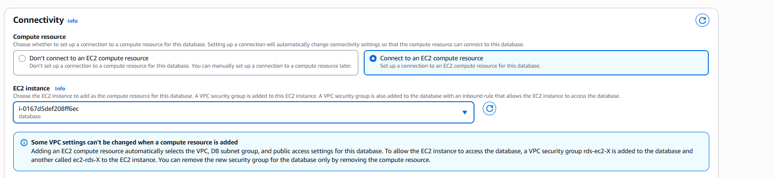
Screenshot Explanation
This screenshot shows the public accessibility configuration for the RDS database.
For a typical secure architecture, the RDS database should remain private and should be accessed by application servers such as EC2 instances inside the VPC.

17. STEP 14 – CONFIGURE RDS SECURITY GROUP
THIS IS THE IMPORTANT SECURITY GROUP STEP
The RDS database must have a Security Group attached to it.
The RDS Security Group controls which network traffic is allowed to reach the database.
Configure the inbound rule as:
Type : MySQL/Aurora
Protocol : TCP
Port : 3306
Source : EC2 Security Group
Screenshot 14 – RDS Security Group

Screenshot Explanation
This screenshot shows the Security Group associated with the RDS database.
The inbound rule allows the EC2 instance to connect to the RDS MySQL database using TCP port 3306.
The important point is that the EC2 Security Group is used as the source of the RDS inbound rule.
The traffic flow is:
EC2 Instance
|
| TCP 3306
↓
RDS Security Group
|
↓
RDS MySQL Database
This is the correct Security Group relationship for the lab:
EC2 Security Group
↓
Source of RDS inbound rule
↓
RDS Security Group
↓
TCP 3306
Do NOT configure this unnecessarily in production:
Source: 0.0.0.0/0
Port: 3306
That would allow MySQL traffic from anywhere on the internet.
The supplied lab documentation specifically states that the RDS Security Group should permit MySQL traffic from the EC2 client and recommends allowing the RDS Security Group to accept traffic from the EC2 Security Group.

18. STEP 15 – REVIEW AND CREATE RDS
Review:
- Engine
- Version
- Credentials
- Instance class
- Storage
- VPC
- Subnet
- Security Group
- Port
- Availability
Click:
Create Database
Screenshot 15 – Create Database
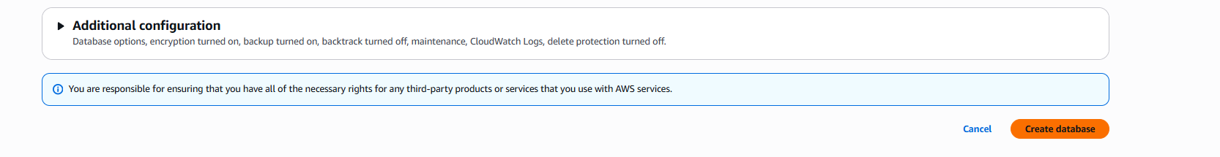Screenshot Explanation
This screenshot shows the final RDS configuration before the database is created.
After clicking Create database, AWS provisions the database according to the selected configuration.

19. STEP 16 – VERIFY RDS STATUS
Wait until:
Status → Available

20. STEP 17 – FIND RDS ENDPOINT
Open the RDS database details.
Find:
Endpoint
Port
Example:
Endpoint:
database.xxxxxxxxx.ap-south-1.rds.amazonaws.com

Port:
3306
Screenshot 17 – RDS Endpoint

Screenshot Explanation
This screenshot shows the RDS database endpoint and port.
The endpoint is a DNS address used by clients and applications to connect to the RDS database.
MySQL normally uses TCP port:
3306
The supplied lab documentation also identifies TCP 3306 as the normal MySQL port.

21. STEP 18 – CONNECT TO EC2 USING SSH
Use:
ssh -i <key-file.pem> ec2-user@<PUBLIC-IP>
Screenshot 18 – SSH Connection
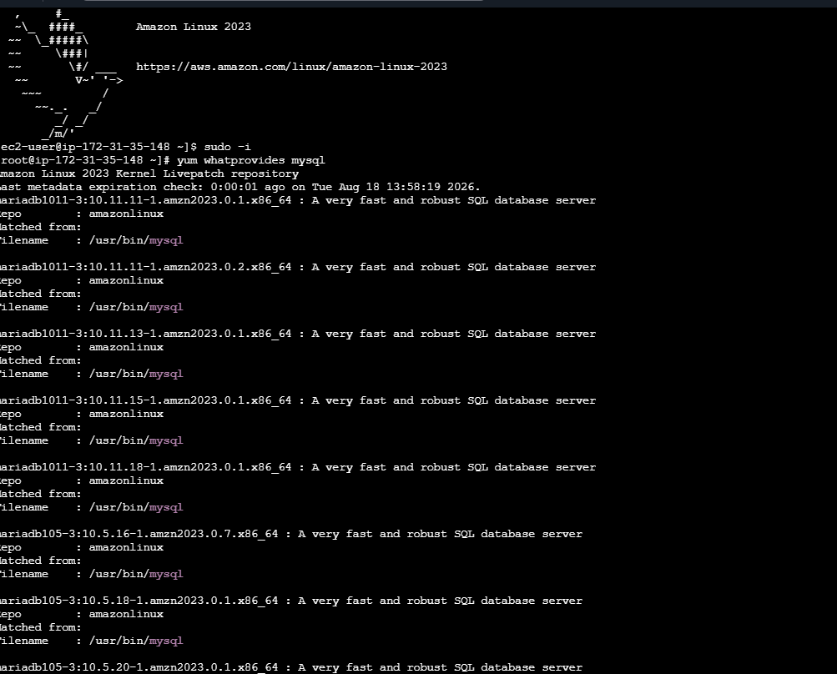Screenshot Explanation
This screenshot shows the successful SSH connection to the Linux EC2 instance.
The EC2 instance will be used as the client from which the RDS MySQL database will be accessed.

22. STEP 19 – SWITCH TO ROOT USER
Run:
sudo -i
Screenshot 19 – Root User
[INSERT SCREENSHOT HERE]
Screenshot Explanation
This screenshot shows the Linux terminal after switching to the root user.
Root access provides administrative privileges required for installing packages and performing system-level configuration.

23. STEP 20 – SEARCH FOR MYSQL PACKAGE
Run:
yum search mysql
Screenshot 20 – MySQL Package Search
Screenshot Explanation
This screenshot shows the MySQL-related packages available in the configured Linux repositories.
The purpose of this step is to identify the required MySQL client package that will be used to connect to the RDS database.

24. STEP 21 – INSTALL MYSQL CLIENT
Install the required client package.

Example:
yum install <mysql-client-package>
Verify:
mysql --version
Screenshot 21 – MySQL Client Installation
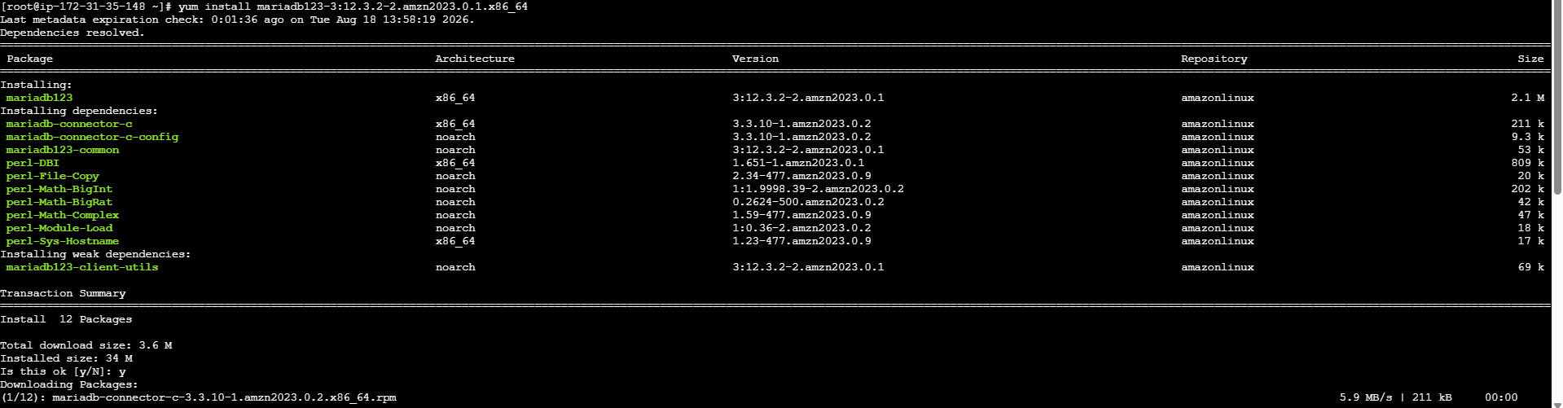Screenshot Explanation
This screenshot confirms that the MySQL client has been installed on the Linux EC2 instance.
The MySQL client provides the command-line interface required to connect to and manage the RDS MySQL database.

25. STEP 22 – CONNECT EC2 TO RDS
Run:
mysql -h <RDS-ENDPOINT> -P 3306 -u <MASTER-USERNAME> -p
Screenshot 22 – RDS Connection Command
[INSERT SCREENSHOT HERE]
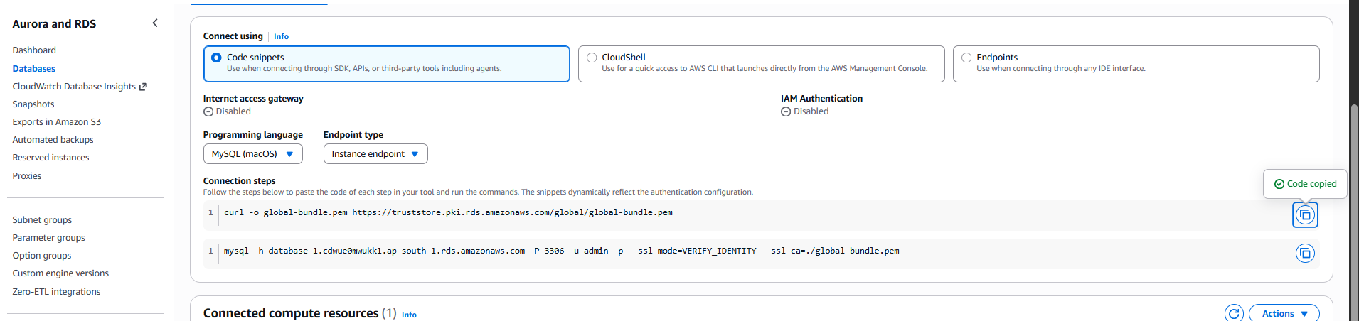This screenshot shows the command used to connect from the EC2 instance to the RDS database.
The parameters are:
-h → RDS endpoint
-P → Database port
-u → Database username
-p → Prompt for password
The command uses TCP port 3306 to communicate with the RDS MySQL database.
The password should be entered only when prompted.

26. STEP 23 – SUCCESSFUL MYSQL CONNECTION
Screenshot 23 – MySQL Connection Successful

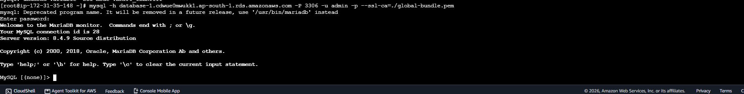Screenshot Explanation
This screenshot confirms that the EC2 instance successfully connected to the RDS MySQL database.
This proves that:
- EC2 is running.
- RDS is available.
- The RDS endpoint is correct.
- The Security Group allows TCP 3306.
- The MySQL client is installed.
- The database credentials are valid.

27. STEP 24 – SHOW DATABASES
Run:
SHOW DATABASES;
Screenshot 24 – SHOW DATABASES
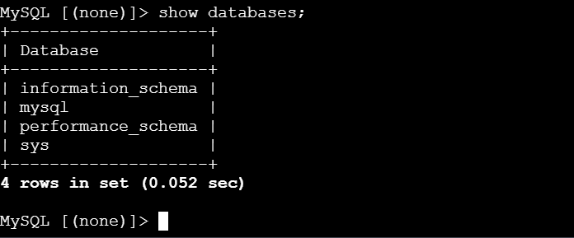
Screenshot Explanation
This screenshot shows the databases available in the RDS MySQL instance.
The SHOW DATABASES; command is used to verify that the MySQL client is connected successfully and can communicate with the database server.

28. STEP 25 – CREATE DATABASE
Run:
CREATE DATABASE barath;
Then:
SHOW DATABASES;
Screenshot 25 – Database Creation
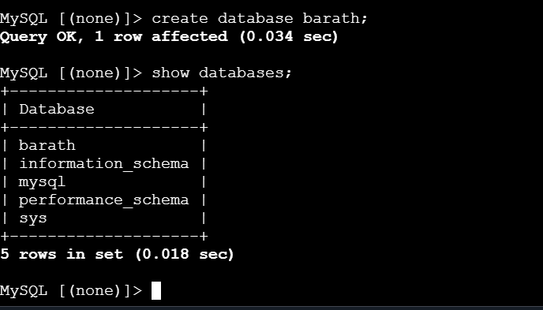Screenshot Explanation
This screenshot shows the creation of a new database named barath.
This database will be used to create sample data that can later be verified on the Read Replica.

29. STEP 26 – SELECT DATABASE
Run:
USE barath;
Screenshot 26 – USE Database
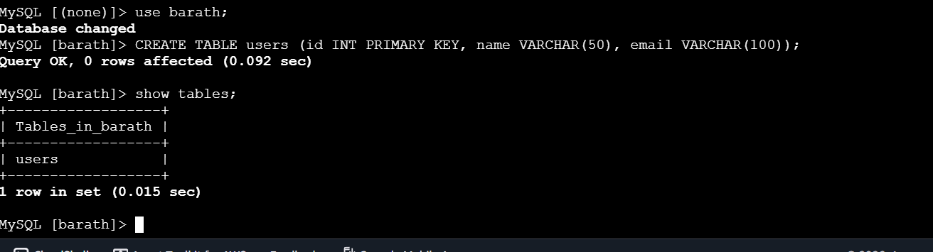
Screenshot Explanation
This screenshot confirms that the barath database has been selected.
All tables created after this command will be created inside the selected database.

30. STEP 27 – CREATE TABLE
Run:
CREATE TABLE users (
id INT PRIMARY KEY,
name VARCHAR(50),
email VARCHAR(100)
);
Then:
SHOW TABLES;
Screenshot 27 – Users Table
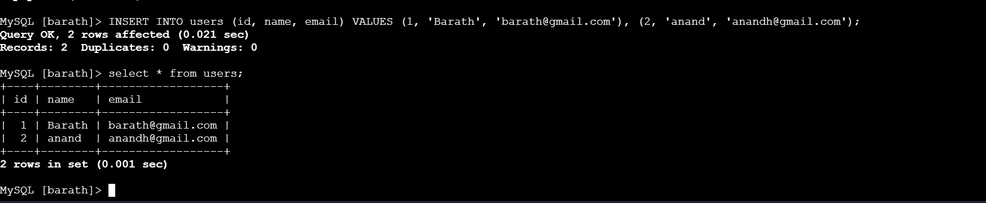
Screenshot Explanation
This screenshot shows the creation of the users table.
The table contains three columns:
id
name
email
The id column is defined as the primary key and uniquely identifies each record.

31. STEP 28 – INSERT SAMPLE DATA
Run:
INSERT INTO users
VALUES
(1, 'Barath', 'barath@example.com'),
(2, 'Anand', 'anand@example.com');
Screenshot 28 – Insert Sample Data
Screenshot Explanation
This screenshot shows the insertion of sample records into the users table.
The sample data is important because it will be used later to verify whether the data has successfully replicated to the Read Replica.

32. STEP 29 – VERIFY DATA
Run:
SELECT * FROM users;
confirms that the sample records were successfully inserted into the original RDS database.
This data will be used as the baseline for testing replication.

33. STEP 30 – CREATE READ REPLICA
Go to:
RDS
↓
Databases
↓
Select Source Database
↓
Actions
↓
Create Read Replica
Screenshot 30 – Create Read Replica
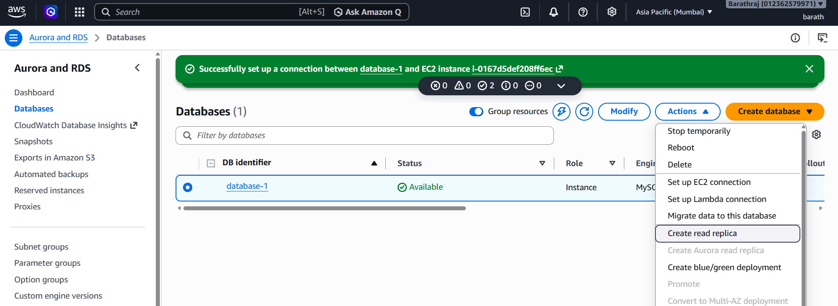Screenshot Explanation
This screenshot shows the Create Read Replica option in Amazon RDS.
A Read Replica is a separate database instance that receives replicated data from the source database.
The primary purpose of a Read Replica is to improve read scalability.

34. STEP 31 – CONFIGURE READ REPLICA
Configure:
- Replica identifier
- Region
- Instance class
- Storage
- VPC
- Subnet
- Security Group
Screenshot 31 – Replica Configuration
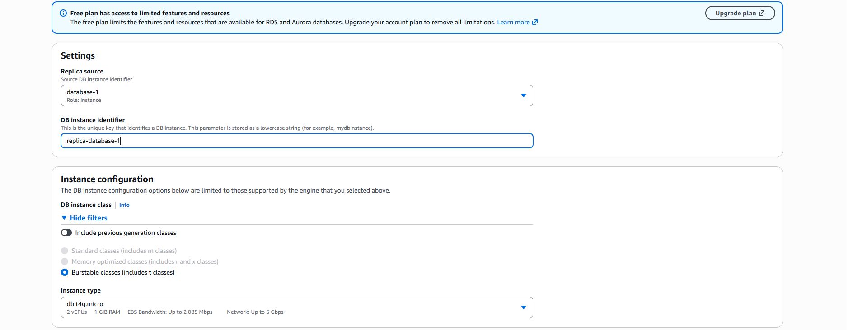
Screenshot Explanation
This screenshot shows the configuration of the Read Replica.
The replica is configured using the required compute, storage, networking, and security settings.
The replica can be created in the same Region or, where supported, another AWS Region.

35. STEP 32 – VERIFY REPLICA STATUS
Wait until:
Replica Status → Available
Screenshot 32 – Read Replica Available
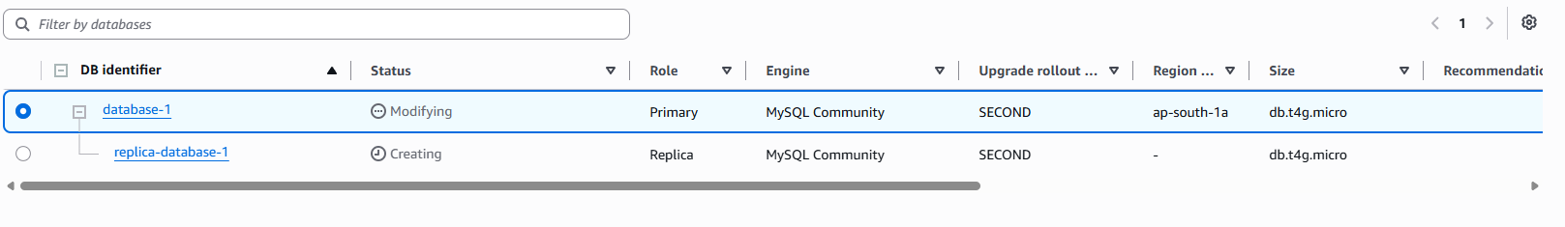
Screenshot Explanation
This screenshot confirms that the Read Replica has been successfully created.
The replica is now available to receive and serve replicated database data.

36. STEP 33 – SOURCE AND REPLICA
shows the relationship between the original RDS database and the Read Replica.
The source database contains the original data, while the Read Replica receives replicated changes.
Source Database
|
| Replication
↓
Read Replica

37. STEP 34 – REPLICA ENDPOINT
Open the Read Replica details and locate the replica endpoint, then delete the original database and check the Wheater the data is available or not
Screenshot 34 – Replica Endpoint
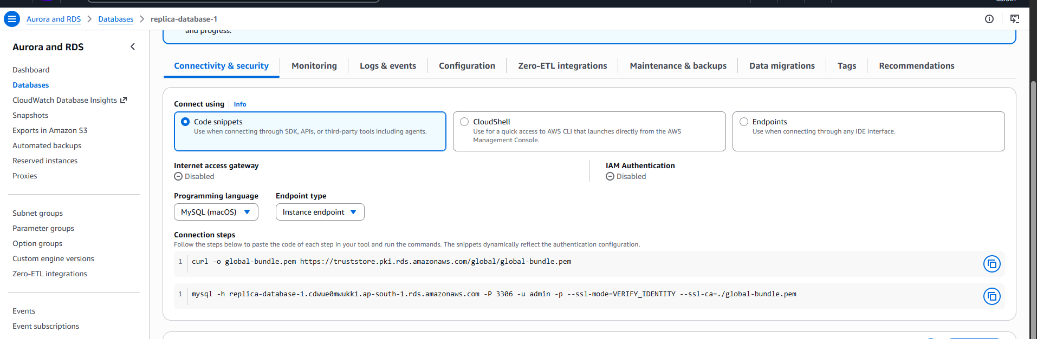
This screenshot shows the endpoint assigned to the Read Replica.
The replica has its own endpoint, which is used when connecting directly to the replica.

38. STEP 35 – CONNECT TO READ REPLICA
Run:
mysql -h <REPLICA-ENDPOINT> -P 3306 -u <MASTER-USERNAME> -p
Screenshot 35 – Replica Connection
[INSERT SCREENSHOT HERE]
Screenshot Explanation
This screenshot shows the Linux EC2 instance connecting to the Read Replica.
The connection confirms that the EC2 instance can communicate with the replica using the replica endpoint and MySQL TCP port 3306.
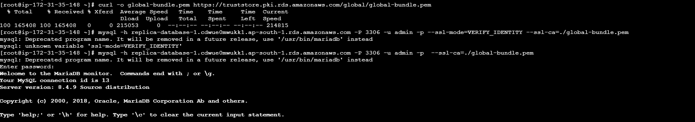

39. STEP 36 – VERIFY REPLICATED DATABASE
Run:
SHOW DATABASES;
Then:
USE barath;
Then:
SHOW TABLES;
Screenshot 36 – Replicated Database
[INSERT SCREENSHOT HERE]
Screenshot Explanation
This screenshot confirms that the database and table created on the original RDS database are available on the Read Replica.
This demonstrates successful replication of the database structure and data.
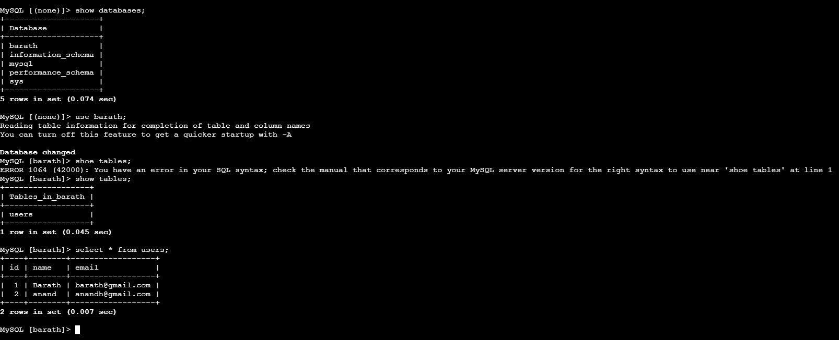

40. STEP 37 – VERIFY REPLICATED DATA
Run:
SELECT * FROM users;
Screenshot 37 – Replicated Records
Screenshot Explanation
This is one of the most important screenshots in the lab.
It confirms that the sample records created in the original database are available on the Read Replica.
This verifies that the required data has been replicated before performing the source database deletion test.
The supplied documentation specifically requires verifying the replica data before removing the original database.

42. STEP 39 – DELETE ORIGINAL DATABASE
Go to:
RDS
↓
Databases
↓
Select Original Database
↓
Actions
↓
Delete
Screenshot 39 – Delete Original RDS
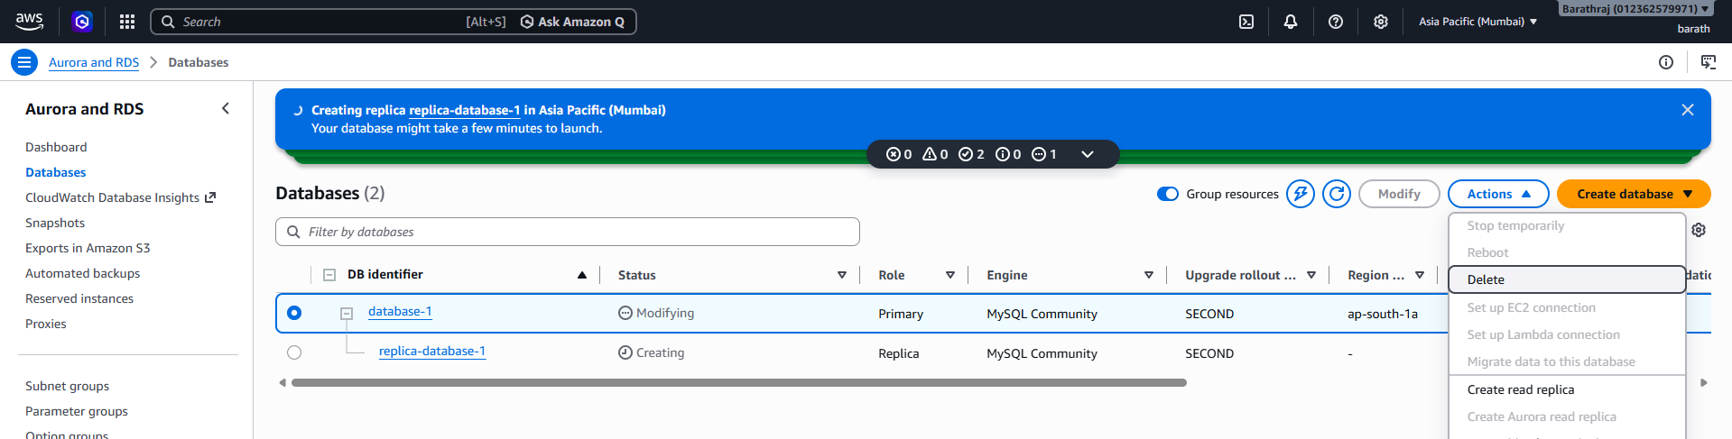
Screenshot Explanation
This screenshot shows the deletion process for the original RDS database.
This is performed as a controlled lab test to verify that the replicated data remains available on the Read Replica.
In a production environment, a database should not be deleted without a documented migration, backup, failover, and recovery plan.
The supplied lab documentation identifies this as a destructive lab operation.

43. STEP 40 – DELETE CONFIRMATION
Screenshot 40 – Delete Confirmation
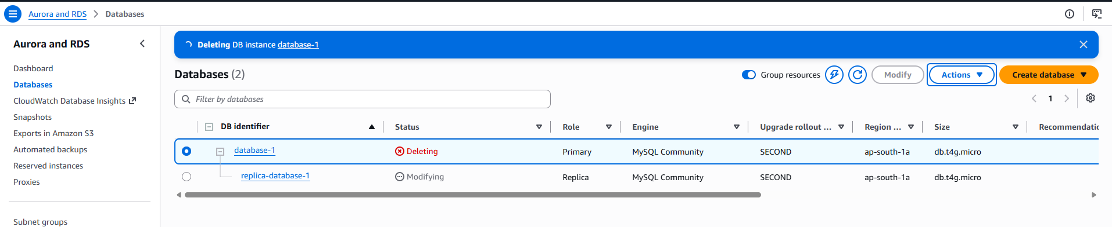
Screenshot Explanation
This screenshot shows the final confirmation screen before deleting the original RDS database.
Before confirming deletion, the administrator should ensure that:
- The replica is available.
- Required data is present on the replica.
- A snapshot has been created if required.
- The deletion is intentional.
- 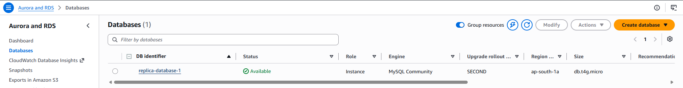

44. STEP 41 – CONNECT TO REPLICA AFTER SOURCE DELETION
Run:
mysql -h <REPLICA-ENDPOINT> -P 3306 -u <MASTER-USERNAME> -p
Screenshot 41 – Replica After Source Deletion
Screenshot Explanation
This screenshot shows the EC2 instance connecting to the Read Replica after the original source database has been removed.
This demonstrates that the replica is still available as a separate database instance.

45. STEP 42 – VERIFY DATA AFTER SOURCE DELETION
Run:
SHOW DATABASES;
Then:
USE barath;
Then:
SELECT * FROM users;
Screenshot 42 – Data Available After Source Deletion

Screenshot Explanation
This is a key validation screenshot.
It demonstrates that the replicated database and sample records are still available on the replica after the source database was removed.
The lab reference follows this same validation approach.

46. IMPORTANT NOTE ABOUT READ REPLICA
A Read Replica should not be described simply as a standby database that automatically becomes the primary when the original database is deleted.
The Read Replica must be promoted when it needs to become an independent primary database.
Therefore:
Read Replica
↓
Primarily Read Scalability
while:
Multi-AZ
↓
High Availability / Failover
The supplied lab documentation specifically distinguishes these two concepts.

47. STEP 43 – CREATE RDS SNAPSHOT
Go to:
RDS
↓
Databases / Snapshots
↓
Select Database
↓
Actions
↓
Take Snapshot
Screenshot 43 – Take DB Snapshot
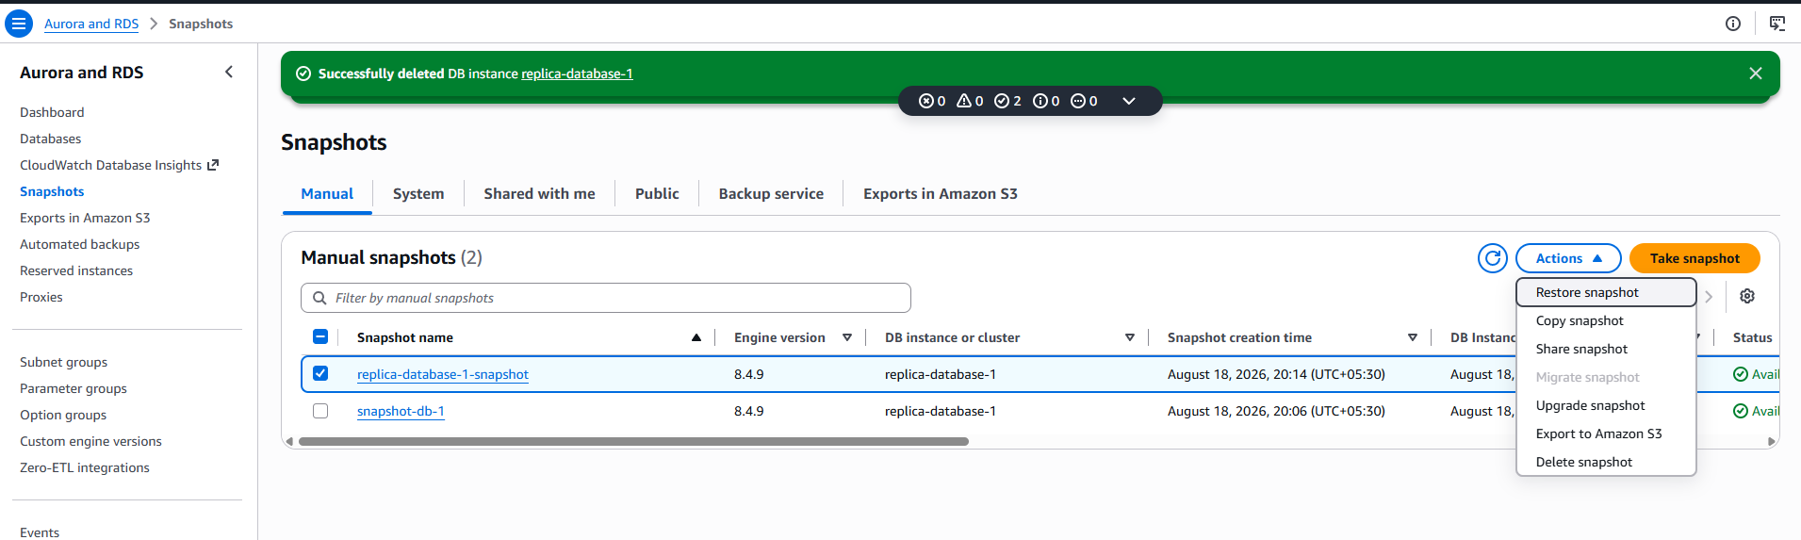Screenshot Explanation
This screenshot shows the process of creating an RDS DB snapshot.
An RDS snapshot is a point-in-time backup of the database.
The snapshot can later be used to create a new RDS database.
The supplied lab documentation includes snapshot creation as part of the recovery workflow.

48. STEP 44 – ENTER SNAPSHOT NAME
Example:
rds-lab-snapshot
Screenshot 44 – Snapshot Identifier
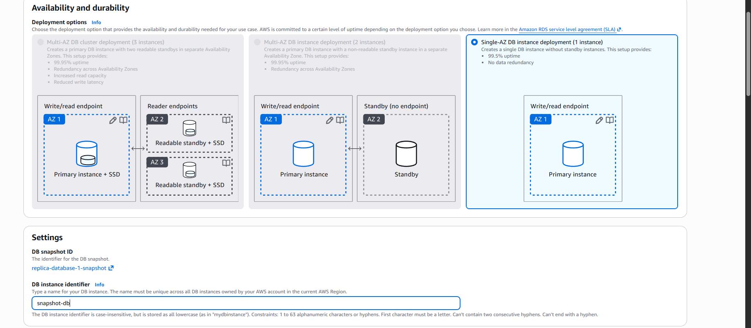Screenshot Explanation
This screenshot shows the name assigned to the RDS snapshot.
A meaningful snapshot name makes it easier to identify the purpose of the backup.

49. STEP 45 – VERIFY SNAPSHOT
Wait until:
Snapshot Status → Available
Screenshot 45 – Snapshot Available
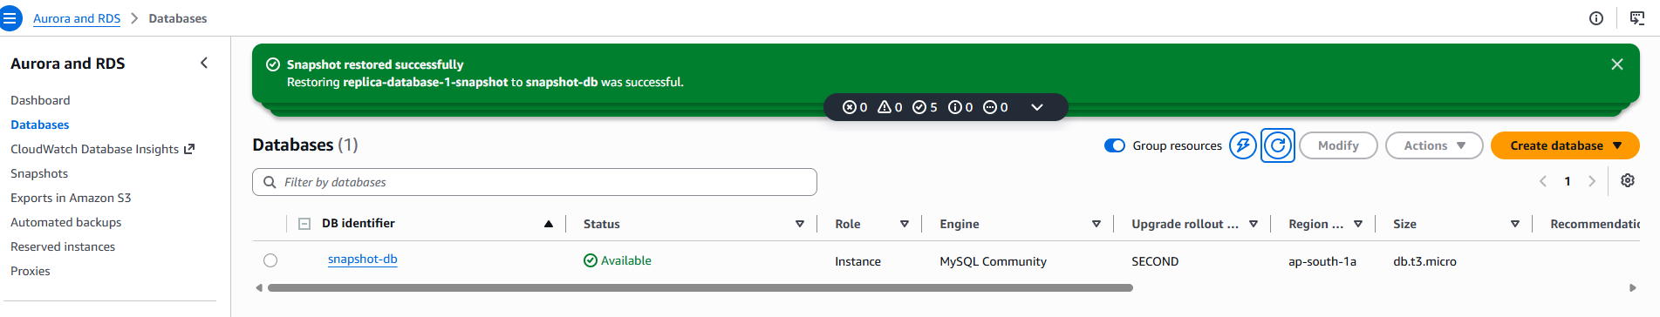Screenshot Explanation
This screenshot confirms that the RDS snapshot has been successfully created and is available for restoration.

50. STEP 46 – DELETE READ REPLICA
After completing the replica test and taking the required snapshot, delete the replica if it is no longer needed.
Go to:
RDS
↓
Databases
↓
Select Replica
↓
Actions
↓
Delete
Screenshot 46 – Delete Replica
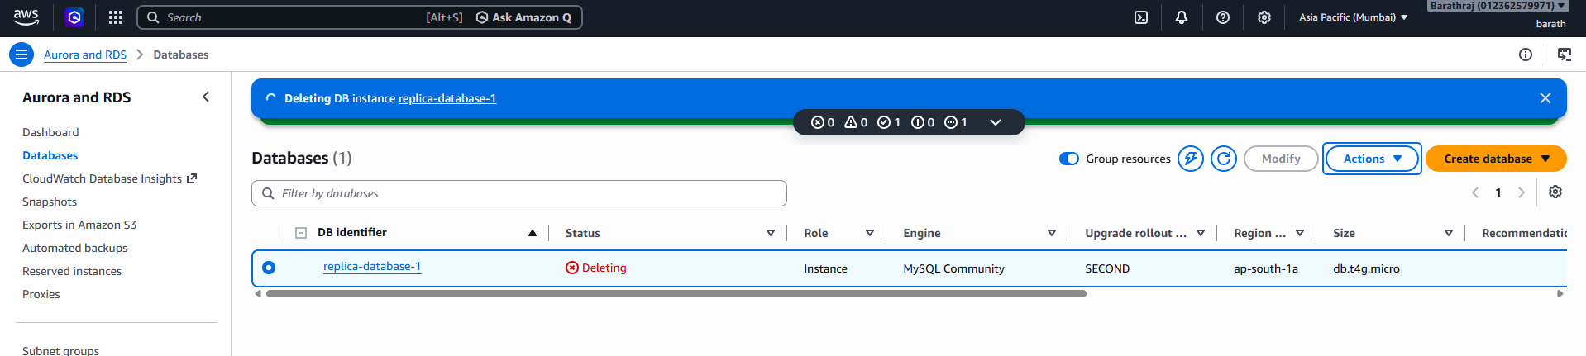Screenshot Explanation
This screenshot shows the deletion of the Read Replica as part of the lab cleanup process.
Unused RDS instances can generate charges, so resources should be deleted when the lab is completed and no longer required.

51. STEP 47 – OPEN RDS SNAPSHOTS
Go to:
RDS
↓
Snapshots
Screenshot 47 – Snapshot List
Screenshot Explanation
This screenshot shows the RDS snapshots available in the AWS account.
The snapshot created earlier can be selected and used to restore a new RDS database.

52. STEP 48 – RESTORE DATABASE FROM SNAPSHOT
Select:
Actions
↓
Restore Snapshot
Screenshot 48 – Restore Snapshot
Screenshot Explanation
This screenshot shows the RDS snapshot restoration process.
Restoring a snapshot creates a new RDS database instance using the snapshot data.
The snapshot itself remains available as a backup.

53. STEP 49 – CONFIGURE RESTORED DATABASE
Configure:
- DB instance identifier
- Instance class
- Storage
- VPC
- Subnet
- Security Group
- Availability
- Other required settings
Screenshot 49 – Restore Configuration
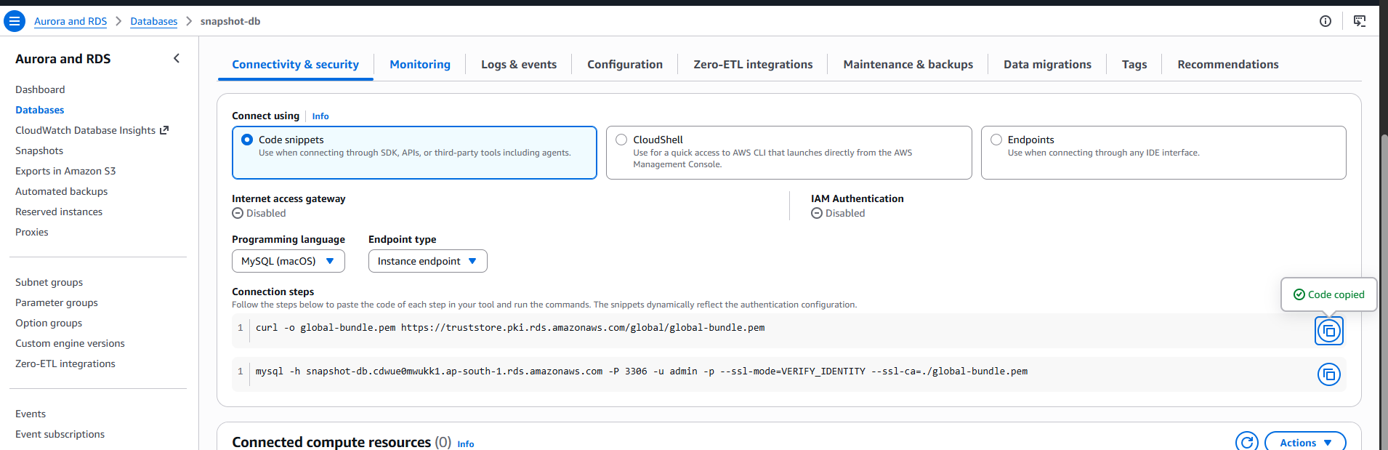Screenshot Explanation
This screenshot shows the configuration options used while restoring the database.
The restored database can be configured with the required compute, storage, networking, security, and availability settings.
The supplied lab documentation specifically identifies these restore settings.

54. STEP 50 – RESTORE DATABASE
Click:
Restore DB Instance
Screenshot 50 – Restore DB Instance
Screenshot Explanation
This screenshot shows the final step of restoring the database from the RDS snapshot.
AWS creates a new RDS database instance using the selected snapshot as the source.

55. STEP 51 – VERIFY RESTORED DATABASE
Wait until:
Status → Available
Screenshot 51 – Restored Database Available
Screenshot Explanation
This screenshot confirms that the restored RDS database has finished provisioning and is available for connections.

56. STEP 52 – GET RESTORED DATABASE ENDPOINT
Open the restored RDS database and copy its endpoint.
Screenshot 52 – Restored RDS Endpoint
[INSERT SCREENSHOT HERE]
Screenshot Explanation
This screenshot shows the endpoint of the newly restored RDS database.
The endpoint is used by the EC2 instance to connect to the restored database.

57. STEP 53 – CONNECT TO RESTORED DATABASE
Run:
mysql -h <RESTORED-RDS-ENDPOINT> -P 3306 -u <MASTER-USERNAME> -p
Screenshot 53 – Restored Database Connection
Screenshot Explanation
This screenshot confirms that the Linux EC2 instance can successfully connect to the restored RDS database.
This verifies that the restored database is available and reachable through the configured networking and Security Group rules.

58. STEP 54 – VERIFY RESTORED DATABASE
Run:
SHOW DATABASES;
Then:
USE barath;
Then:
SHOW TABLES;
Screenshot 54 – Restored Database
Screenshot Explanation
This screenshot confirms that the database and table were successfully restored from the snapshot.

59. STEP 55 – VERIFY RESTORED DATA
Run:
SELECT * FROM users;
Screenshot 55 – Restored Data
Screenshot Explanation
This is the final data validation screenshot.
It confirms that the sample records created during the original RDS database setup are available after restoring the database from the snapshot.
This demonstrates that the RDS snapshot can be used as a recovery point.

60. RDS SECURITY GROUP – FINAL EXPLANATION
The Security Group configuration is one of the most important parts of this lab.
The final network flow is:
EC2
|
|
EC2 Security Group
|
| TCP 3306
|
↓
RDS Security Group
|
↓
RDS MySQL
The RDS inbound rule should be:
Type : MySQL/Aurora
Protocol : TCP
Port : 3306
Source : EC2 Security Group
Explanation
The EC2 instance initiates the connection to the RDS database.
The RDS Security Group checks the incoming traffic.
If the traffic comes from the allowed EC2 Security Group and uses TCP port 3306, the connection is allowed.
This configuration provides controlled network access between the EC2 instance and RDS database.

61. SECURITY BEST PRACTICES
61.1 Do Not Open Port 3306 to Everyone
Avoid:
0.0.0.0/0
for production database access.

61.2 Use EC2 Security Group as the Source
Recommended:
RDS Security Group
↓
Inbound
↓
TCP 3306
↓
EC2 Security Group

61.3 Keep RDS Private
A database normally does not need to be directly exposed to the internet.
Recommended architecture:
Internet
↓
Application / Load Balancer
↓
EC2
↓
RDS

61.4 Protect Credentials
Never expose:
- Database passwords
- AWS access keys
- Private keys
- SSH keys
- Secret tokens

62. TROUBLESHOOTING
Problem 1 – Cannot Connect to RDS
Check:
RDS Status
↓
Security Group
↓
TCP 3306
↓
EC2 Security Group
↓
VPC
↓
Subnet
↓
RDS Endpoint

Problem 2 – Connection Timeout
Possible causes:
- RDS Security Group does not allow port 3306.
- Wrong source Security Group.
- EC2 and RDS networking is not configured correctly.
- Incorrect endpoint.
- Database is not available.

Problem 3 – MySQL Command Not Found
Check:
mysql --version
If the command is unavailable, install the appropriate MySQL/MariaDB client package.

63. LAB VALIDATION CHECKLIST
Use this checklist at the end of the documentation.
[✓] EC2 instance created

[✓] EC2 instance running

[✓] SSH access configured

[✓] RDS MySQL database created

[✓] VPC configured

[✓] Subnet configured

[✓] RDS Security Group attached

[✓] RDS Security Group allows TCP 3306

[✓] EC2 Security Group configured

[✓] EC2 Security Group used as RDS inbound source

[✓] RDS database status = Available

[✓] RDS endpoint identified

[✓] MySQL client installed

[✓] EC2 connected to RDS

[✓] Database created

[✓] Table created

[✓] Sample data inserted

[✓] Data verified

[✓] Read Replica created

[✓] Replica status verified

[✓] Replica endpoint identified

[✓] Replica connection successful

[✓] Replicated data verified

[✓] Source database removed as lab test

[✓] Replica data verified after source removal

[✓] RDS snapshot created

[✓] Snapshot status = Available

[✓] Snapshot restored

[✓] Restored database available

[✓] Restored database connection successful

[✓] Restored data verified

[✓] Unused resources cleaned up
This matches the major validation points in the supplied RDS lab documentation.

64. IMPORTANT INTERVIEW QUESTIONS
Q1. What is Amazon RDS?
Amazon RDS is a managed relational database service provided by AWS.

Q2. What is the purpose of the RDS Security Group?
The RDS Security Group controls network traffic allowed to reach the RDS database.

Q3. Which port does MySQL use?
TCP 3306

Q4. Why did we allow port 3306?
Port 3306 is the default TCP port used by MySQL for client-to-database communication.

Q5. What should be the source of the RDS inbound rule?
For this EC2-to-RDS architecture:
EC2 Security Group

Q6. What is a Read Replica?
A Read Replica is a separate database instance that receives replicated data from a source database and is primarily used for read scalability.

Q7. What is Multi-AZ?
Multi-AZ is used primarily to improve database high availability and provide failover capabilities.

Q8. Read Replica vs Multi-AZ?
Read Replica
→ Read Scalability

Multi-AZ
→ High Availability / Failover

Q9. What is an RDS Snapshot?
An RDS Snapshot is a point-in-time backup of an RDS database that can be used to restore a new database.

Q10. Why did we use EC2?
The EC2 instance acts as the Linux client from which we connect to the RDS MySQL database.

65. FINAL LAB RESULT
The lab successfully demonstrates the complete AWS RDS workflow:
EC2 INSTANCE
↓
RDS MYSQL
↓
VPC
↓
SUBNET
↓
RDS SECURITY GROUP
↓
TCP 3306
↓
MYSQL CLIENT
↓
DATABASE
↓
TABLE
↓
SAMPLE DATA
↓
READ REPLICA
↓
REPLICATION VERIFICATION
↓
SOURCE DATABASE REMOVAL
↓
REPLICA DATA VERIFICATION
↓
RDS SNAPSHOT
↓
SNAPSHOT RESTORE
↓
RESTORED DATABASE
↓
DATA VALIDATION
↓
RESOURCE CLEANUP

